

Completing GOLDS Checkpoints
Log in to your Teaching Strategies Gold Account on the computer.(internet)  Go to the assess tab.  While in the Assess area (1), select Checkpoints in the top navigation menu (2). | 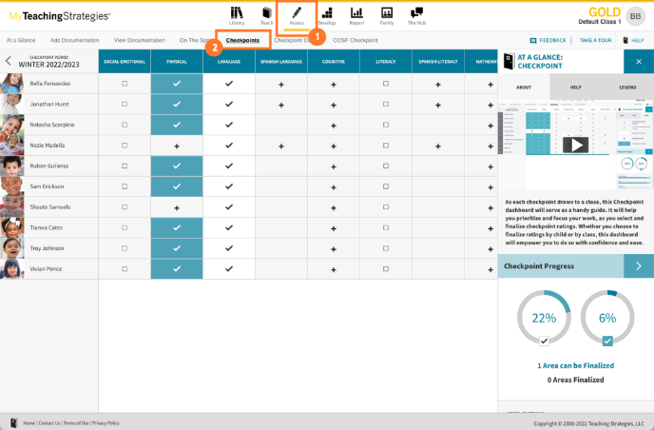
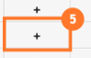  What you see:  A plus sign -no checkpoint rating  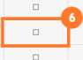  An empty square -there is at least one checkpoint rating entered for an area, but not all objectives and dimensions in that area have entered checkpoint ratings.  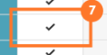  A check mark with a white background -objectives and dimensions in that area have entered checkpoint ratings.  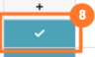  A check mark with a colored background- area is finalized  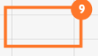  A blank cell - the area is not required for the child. | 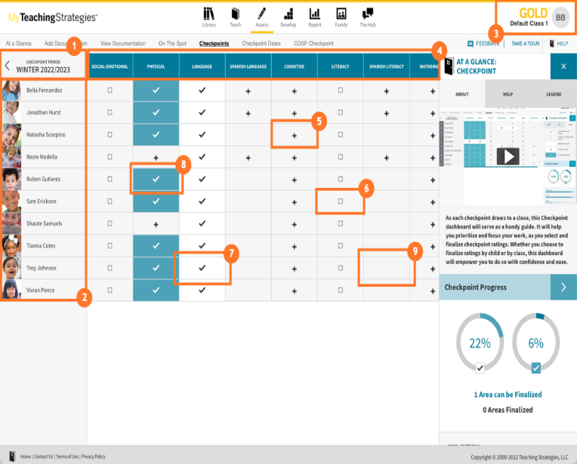
Click on checkpoints  Selecting the domain on top.  Click on the objective | 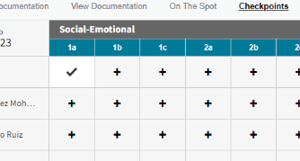  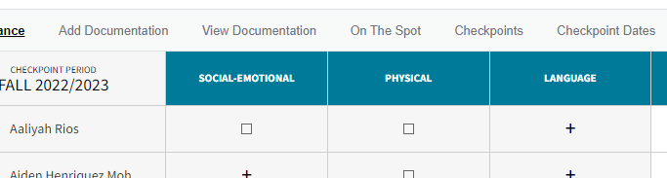
You will see a list of your students along with a number in a folder.  The number in the folder represents how many pieces of evidence you have for this objective.  The number on these folders represents the amount of documentation with a preliminary level of that corresponding level. For example, a folder with a "2" listed under Level 6 represents that you have two pieces of documentation for the child with Level 6 selected as the preliminary level.  Select one of these folders to view all of those documentation items. | 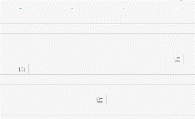  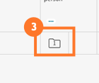
-If there is a documentation folder under a level you wish to select, click the box directly to the right of the folder (1).  -Enter your rating for students by clicking on each box of the level and going down through your class.  -To save your selections at any time, select the arrow (3) next to "Save and Continue", then select "Save" (4)  Press save and continue to complete objectives 1-10.  After each objective a button will come up to finalize all students. If you have data for all students press finalize. | 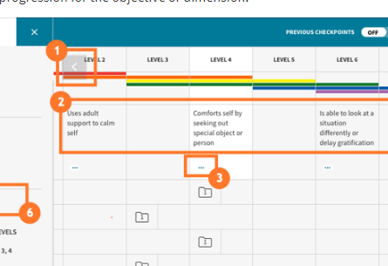
Finalizing GOLDS Checkpoints
Once all checkpoint ratings are entered for one or more children, you can finalize for just that child or multiple children at once. And if every child in your class has checkpoint ratings for an area, you can finalize that area.
Finalize For One Child or Multiple Children( missing documentation- absent students)  -After selecting an area on the Checkpoints dashboard , if one or more children have checkpoint ratings entered for all objectives and dimensions in that area , select one of those children's names . | 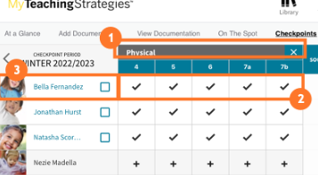
-Select the child or children you wish to finalize , or choose Select All to select all eligible children.  -Select Finalize Selected Children. | 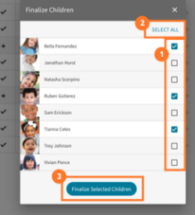
Finalize For All Children  - After selecting an area on the checkpoints dashboard (1), if all objectives and dimensions in that area have entered checkpoint ratings for all children in the class (2), you will be prompted to finalize that area (3).  - Select FINALIZE (4). | 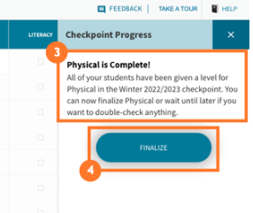
Use the checkpoint area on the bottom to check the checkpoint progress. | 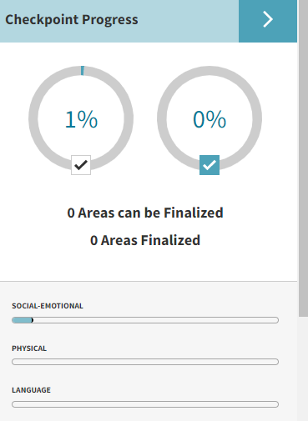
- The selected area is now finalized. If you need to unfinalize an area, you can do so by selecting the area again.
If a child does not have any documentation for an objective or dimension, then you can select "Not Observed" for that item instead of entering a checkpoint rating so that you can still finalize the objective or dimension's area. Note: You should use “Not Observed” with caution.

Videos for help
https://teachingstrategies.force.com/portal/s/GOLD-ready-set-go-videos- Finalizing Checkpoint by Class

